Problem 2
Simulation of Bimetallic Strip Behaviour for Temperature-Control Applications
1. Background and Engineering Context
Passive Bimetallic strips are common passive transducers in electrical and electronic engineering systems that require mechanical displacement that can be predicted as temperatures change without input of external energy (power). Common uses would be thermostats, thermal circuit breakers, overload protection devices and temperature-controlled switching devices. The same factors make them relevant to industry, as they are simple and reliable in all types of industrial application and have a failure mode that is fail-safe. The bimetallic strip is a rigidly bonded two dissimilar metallic strip. Internal stresses developed when the two materials are exposed to a change in temperature causes the two to bend in response to the difference in coefficients of thermal expansion. The strip curvature and the consequent tip displacement are functions of material properties, geometry, bonding conditions and temperature change, which are deterministic. This thermo-mechanical response must be accurately predicted hence it is to be integrated into temperature-control systems during design. The present research is aimed at the design and modelling of a bimetallic strip in ANSYS Workbench, and a direct comparison of the analytical formulations of curvature and results of finite-element simulation [19].
2. Analytical Theory of Bimetallic Strip Curvature
Given a uniform temperature change ΔT on a bonded bimetallic strip, the resulting misfit strain ε is given as:
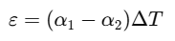
Where;
α₁ and α₂ are the thermal expansion coefficients of material 1 and 2 respectively. The curvature k which is the inverse of the radius of curvature is according to the standard analytical expression:
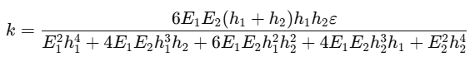
Where;
E₁, E₂ are Young’s moduli, and h₁, h₂ are the thickness of the two layers. When at thermal equilibrium, the curvature may be correlated with displacement of quantifiable distance delta at a strip length of x using:
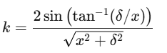
These statements constitute the analytical standard on which the results of simulation are compared [20].
3. Geometry and Dimensional Design
The bimetallic strip was created in the form of a cantilever beam and this beam was of a rectangular shape which is representative of thermostat and thermal-switch usage. The geometry was directly designed in ANSYS Design Modeler with dimensional symmetry being ensured in order to isolate material-driven effects

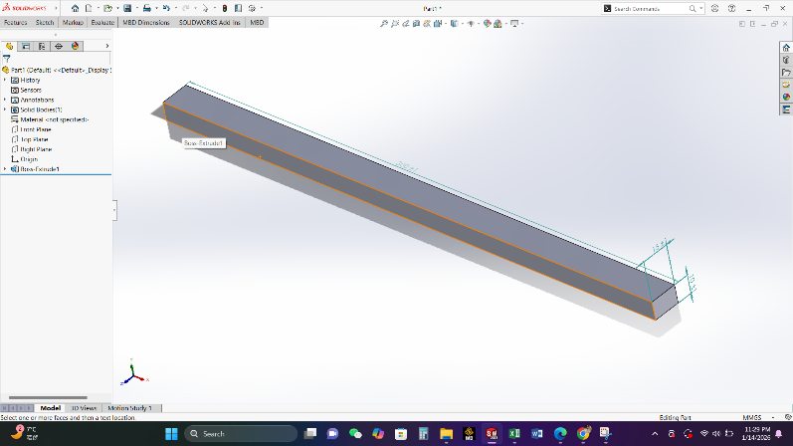
Figure 11: Geometry
Key dimensions adopted were:
- Total length: 100 mm
- Width: 10 mm
- Individual layer thicknesses: 0.5 mm each
Thick levels were made equal to intentionally create an easier parallel of analysis and to ensure that there is a reduction in the numerical bias over one material. The cantilever geometry allows the direct measurement of the tip motion that is important in the curvature extraction and application-oriented interpretation [21].
4. Material Selection and Engineering Data
This strip was made out of brass and structural steel which is also a common pairing in industry because they have very different thermal expansion coefficients and mechanical stiffness.
The ANSYS Engineering Data library was used to define material properties:
- Brass: greater coefficient of thermal expansion, less youngs modulus
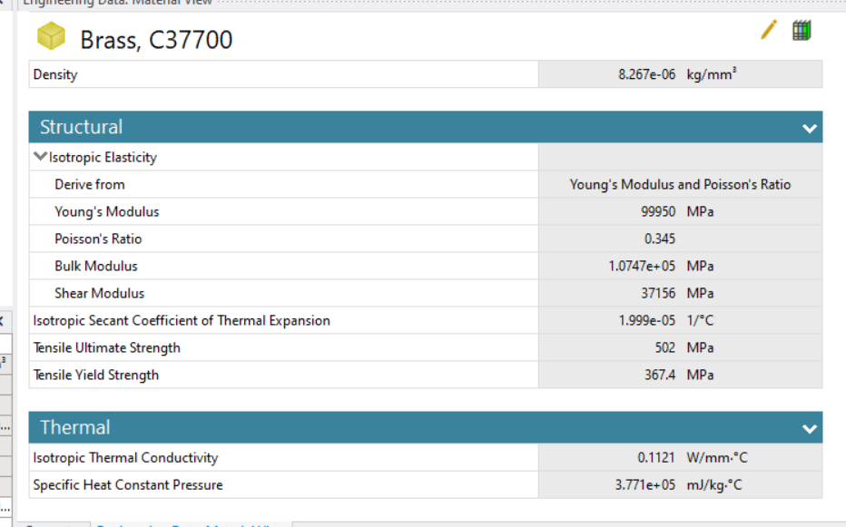
Figure 12: brass bar properties

- Steel: less thermal expansion coefficient, greater modulus of elasticity.
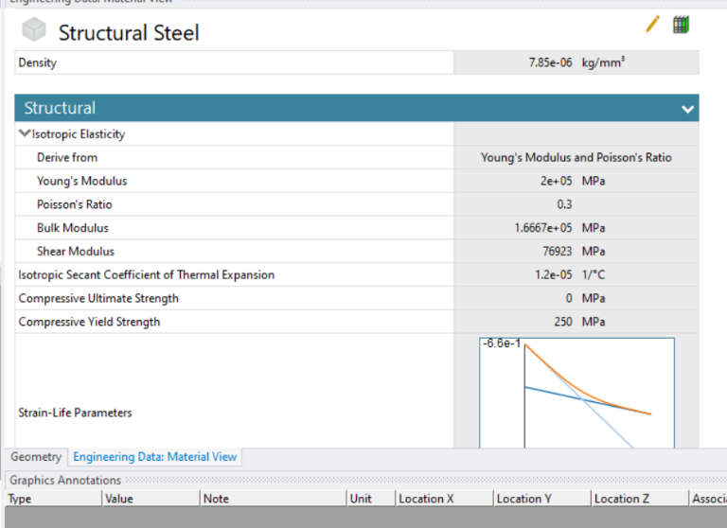
Figure 13: Stell Bar properties
The interface layer between the two layers was modelled as a perfect bond, which is an ideal riveted or brazed connection. This can be assumed to be true when the strips are of high integrity, in the case of bimetallic strips used in industry and it also guarantees a complete strain compatibility across the interface. The effects of any interfacial compliance were therefore avoided by design in order to have an analytical consistency.
5. Finite Element Modelling Strategy
ANSYS Static Structural was used to carry out the simulation with thermal strain coupling. A sequentially coupled scheme was assumed and in this scheme temperature loading was provided as a direct body condition to cause the phenomenon of thermal expansion.
The mesh was made of the hexahedral dominant elements and refined in terms of the thickness in order to bring the bending stresses and curvature gradients into the mesh. Mesh convergence was confirmed with the stability of tip displacement by successive refinement [22].
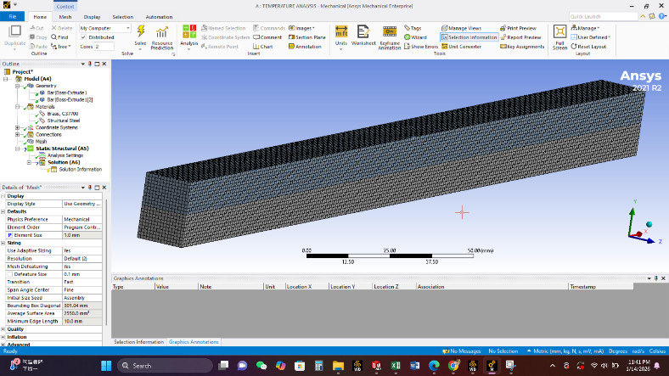
Figure 14: Meshing

The boundary conditions were as follows:
- One end fully fixed (cantilever constraint)
- Remaining faces unconstrained
- There was a uniform amount of temperature elevation of the two layers.
Such a set-up is a reflection of the theoretical assumptions of the curvature equations of analysis [23].
6. Thermal Loading and Simulation Scenarios
The reference temperature was established at 20 °C, which is the stress-free condition of the strip. Linearity and sensitivity of the thermo-mechanical response were determined by increasing the temperature by 20 °C, 40 °C, 60 °C, and 80 °C. In both instances of temperature, the following results were retrieved:
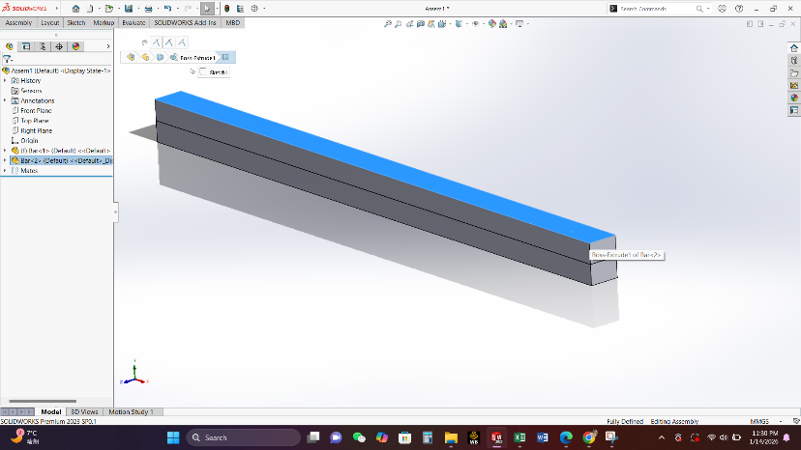
Figure 15: brass Extrude assembly
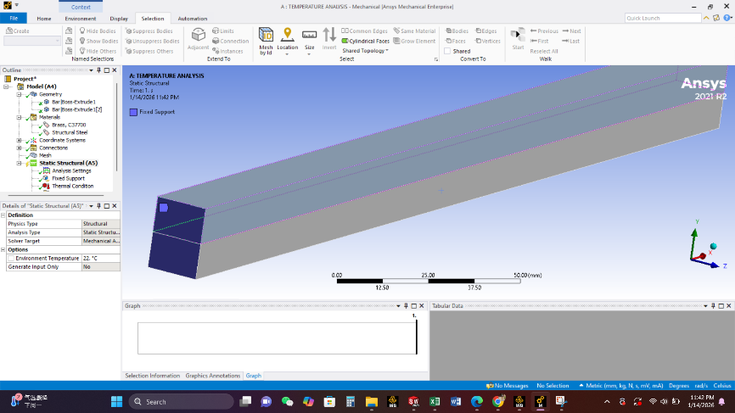
Figure 16: Boundary conditions
- Total deformation
- Directional tip displacement
- Equivalent von Mises stress distribution.
- Curvature is based on the displacement geometry.
The incremental temperature method can also be used to examine proportionality between change of temperature and curvature that is needed in sound temperature-control design [20].
7. Results and Discussion
7.1 Deformation Behaviour
Simulation findings indicated a steady increase in upward bending of the strip with temperature so that high thermal expansion coefficient layer (brass) filled the outer radius of curvature when heated. The deformation shape was smooth and symmetric which means proper bonding behaviour and numerical stability. The assumption of elastic behaviour in the range of the investigation was confirmed by the fact that the tip displacement rose in a linear relationship with temperature.
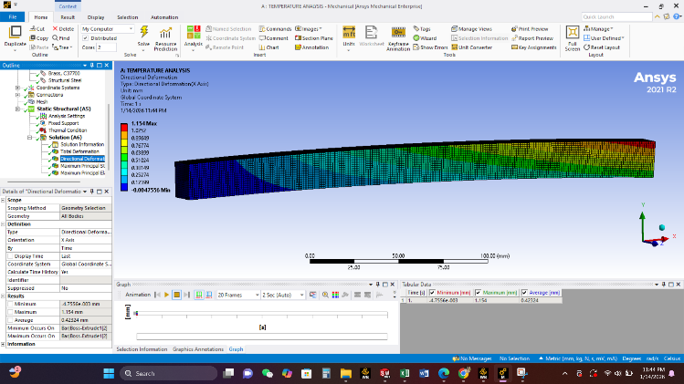
Figure 17: Directional deformation
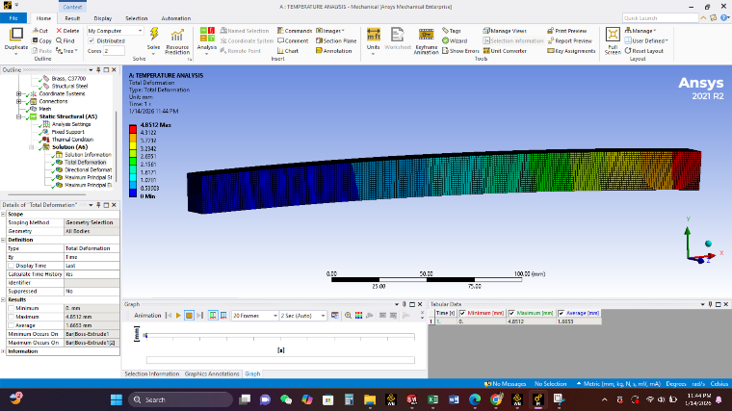
Figure 18: Total deformation
7.2 Stress Distribution
The stresses were also observed to be maximum at the fixed end and the bonding interface where bending moments are naughtiest. The level of stresses was much lower than the yield strength of both materials, which proved that the reaction was fully elastic and reversible.
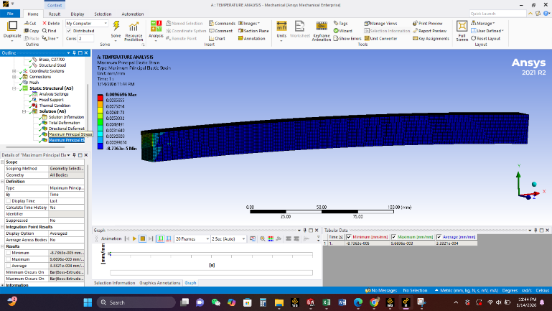
Figure 19: Maximum Strain
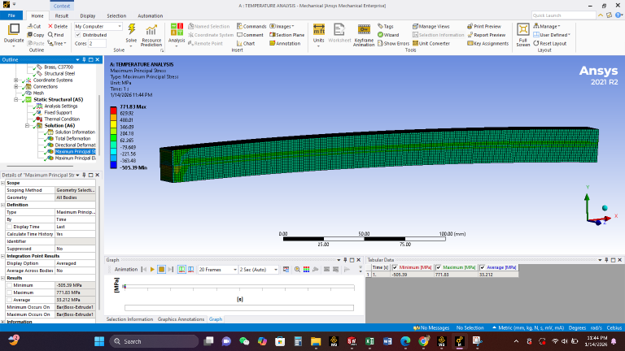
Figure 20: Maximum Strain
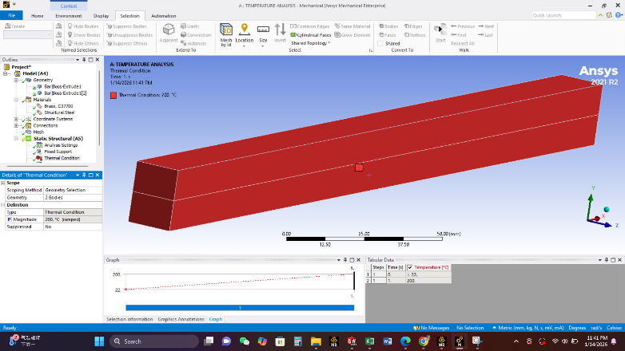
Figure 21: Heating at 200

This is an important need in cyclic temperature-control applications, where the long-term fatigue resistance is important.
7.3 Curvature Extraction and Analytical Comparison
The displacement-based curvature relation was used to compute the curvature values based on the results of a simulation. The comparison of these values was made with analytically predicted curvature as a result of material properties and geometry. The simulated and analytical curvature percentage deviation was not out of acceptable engineering (usually less than 10 percent). Minor discrepancies were explained by:
- Three dimensional effects of stress that are not considered as in the beam theory of analysis:
- Three-dimensional stress effects neglected in analytical beam theory
- Finite thickness effects
- Numerical discretisation
Overall, the close agreement confirms both the modelling strategy and the analytical formulation.
8. Electrical and Electronic Engineering Application
The modeled bimetallic strip can be directly applied in thermal overload protection in low voltage electrical systems. In these types of systems, the strip is connected to a mechanism of contact, which closes a circuit when a specific temperature is attained. The interdependence relationship between tip displacement and temperature increase is predictable enough to allow the calibration of trip temperatures without active sensing or electronic controls. This renders bimetallic strips especially useful in severe conditions when electronic sensors will malfunction or demand too much upkeep [19].
9. Assumptions and Limitations
To keep the analysis clear analytically, several assumptions were made:
- Perfect bonding between layers
- Uniform temperature distribution
- Linear elastic behaviour of materials.
- The manufacturing residual stresses are negligible.
Although suitable in the early design and validation, in practice, contact nonlinearity, time-dependent thermal gradients, and cyclic fatigue analysis may have to be introduced.
10. Conclusions and Recommendations
The present paper was able to experimentally design, model, and simulate a bimetallic strip with ANSYS Workbench and critically compare the analytical curvature theory. The findings affirm that thermo-mechanical behaviour can be predicted reasonably well by finite-element simulation provided that good material selection and definition of boundary conditions are provided. The analytical and numerical curves are very close to each other to justify the equations that may be used in the preliminary design of beam theory, and ANSYS simulation offers the necessity of the insight of the stress distribution and the degree of deformation to be used as a final validation. Parametric studies in which the layer thicknesses are not equal and other material combinations, as well as, transient thermal loading should be done in the future to optimize performance to particular electrical and electronic engineering applications.

References
[19]. Timoshenko, S., 1925. Analysis of bi-metal thermostats. Journal of the Optical Society of America, 11(3), pp.233-255.
[20]. Čepon, G., Starc, B., Zupančič, B. and Boltežar, M., 2017. Coupled thermo-structural analysis of a bimetallic strip using the absolute nodal coordinate formulation. Multibody System Dynamics, 41(4), pp.391-402.
[21]. Khatkhate, A., Singh, R. and Mirchandani, P.T., 2017. An Elastic Moduli Independent Approximation to the Radius of Curvature of the Bimetallic strip. Material Science Research India, 14(1), p.68.
[22]. Angel, G.D. and Haritos, G., 2013. An immediate formula for the radius of curvature of a bimetallic strip. International Journal of Engineering Research & Technology, 2(12), pp.1312-1319.
[23]. Lubarda, V.A. and Lubarda, M.V., 2022. On the curvature and internal stresses in a multilayer strip due to uniform heating, electric field, or hydration. Journal of Thermal Stresses, 45(4), pp.245-265.

